# ABC Inventory Management

# Test Scenario: UAT Scenario 1

Table of Contents

Scenario Description 4

Version Control 4

Test Scripts 4

Use Case 4

Test Components/ Requirements 4

User Groups 5

Test Scripts 5

LIS001: Login Script 5

Script Description 5

Testing Requirements 5

Setup 5

Teardown 5

Script Steps 5

Result Screenshots 5

SRP001: Search Product Script 7

Script Description 7

Testing Requirements 7

Setup 7

Teardown 7

Script Steps 7

Result Screenshots 8

SRP002: Search Product Quantity Script 10

Script Description 10

Testing Requirements 10

Setup 10

Teardown 10

Script Steps 10

Result Screenshots 10

SP001: Send Product Script 12

Script Description 12

Testing Requirements 12

Setup 12

Teardown 12

Script Steps 12

Result Screenshots 13

GR001: Generate Report Script 20

Script Description 20

Testing Requirements 20

Setup 20

Teardown 20

Script Steps 21

Result Screenshots 21

LIS001: Logout Script 23

Script Description 23

Testing Requirements 23

Setup 23

Teardown 23

Script Steps 23

Result Screenshots 23

AP001: Accept Product Script 25

Script Description 25

Testing Requirements 25

Setup 25

Teardown 25

Script Steps 25

Result Screenshots 26

Test Execution 31

# Scenario Description

This scenario is intended to test a business condition when the quantity of product of a specific size needs to be searched in different locations from a warehouse. After checking the quantity in each location, the product must be sent to a store location (STR1) from the warehouse location (WRH1). The products then are physically sent to STR1 use a delivery system. It is then assumed that the warehouse staff will attempt to accept the transfer himself. Since the system will not allow that, when the product in the destination store is physically received, the transfer is accepted in the destination location by the staff belonging to the store (STR1) after the products are physically received by the Store 1 staff.

# Version Control

|  |  |  |  |
| --- | --- | --- | --- |
| Version Number | Date | Author | Description |
| 5.0 | 13/09/2018 | Shirish Maharjan | Initial Draft |
| 5.1 | 14/09/2018 | Shirish Maharjan | First Version (Iteration 5) |
| 5.2 | 18/09/2018 | Shirish Maharjan | Second Version (Iteration 5) |

# Test Scripts

The following are the test scripts that will cover this scenario:

* LI001 Login Script
* LO001 Logout Script
* SRP001 Search Product Script
* SRP002 Search Product Quantity Script
* SP001 Send Product Script
* GR001 Generate Report Script
* AP001 Accept Product Script

# Use Case

The use case covered by this test scenario is as follows:

* Login/ Logout
* Search Product
* Send Product
* Generate Report
* Accept Product

# Test Components/ Requirements

This test scenario covers the following high-level testing requirements:

* Login/ Logout Functionality of the system
* Search Product Functionality of the system
* Send Product Functionality of the system
* Generate Report Functionality of the system
* Accept Product Functionality of the system

# User Groups

* Warehouse Staff
* Store Staff

# Test Scripts

The following are the elaboration of the test script mentioned above:

# LIS001: Login Script

## Script Description

This script follows each step while logging in into the system to access the rest of the functionality of the system. This script will check if each step while logging in into the system is a success. If any step fails to succeed, a bug will be reported, and the test will be conducted again.

## Testing Requirements

This test will cover the login functionality of the system.

## Setup

* The computer in the location is powered on.
* Make sure the computer is connected to the internet.
* Application is launched.
* Warehouse Staff username and password are known.

## Teardown

* User is logged into the system and use other functionalities.

## Script Steps

|  |  |  |  |
| --- | --- | --- | --- |
| Step | Test Action | Expected Results | Pass/Fail |
| 1. | Application is launched. | System displays the ‘Login’ Page with the Username and Password field empty. | Pass |
| 2. | Warehouse staff enters username and password in the username and password field. | System waits till user to click on ‘Login’ button. | Pass |
| 3. | Click on the ‘Login’ button. | System grants access to the user and opens the Homepage | Pass |

### Result Screenshots

**Step 1**

Application launched, and login page is displayed.

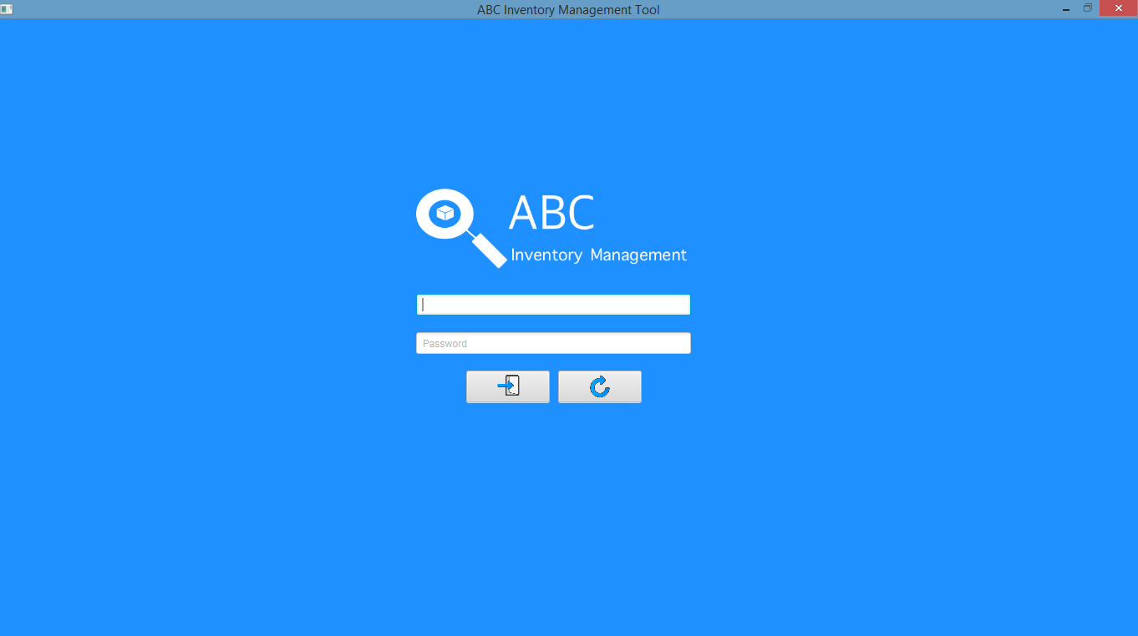

**Step 2**

Username and password are entered, and the system waits user to click on the ‘Login’ button.

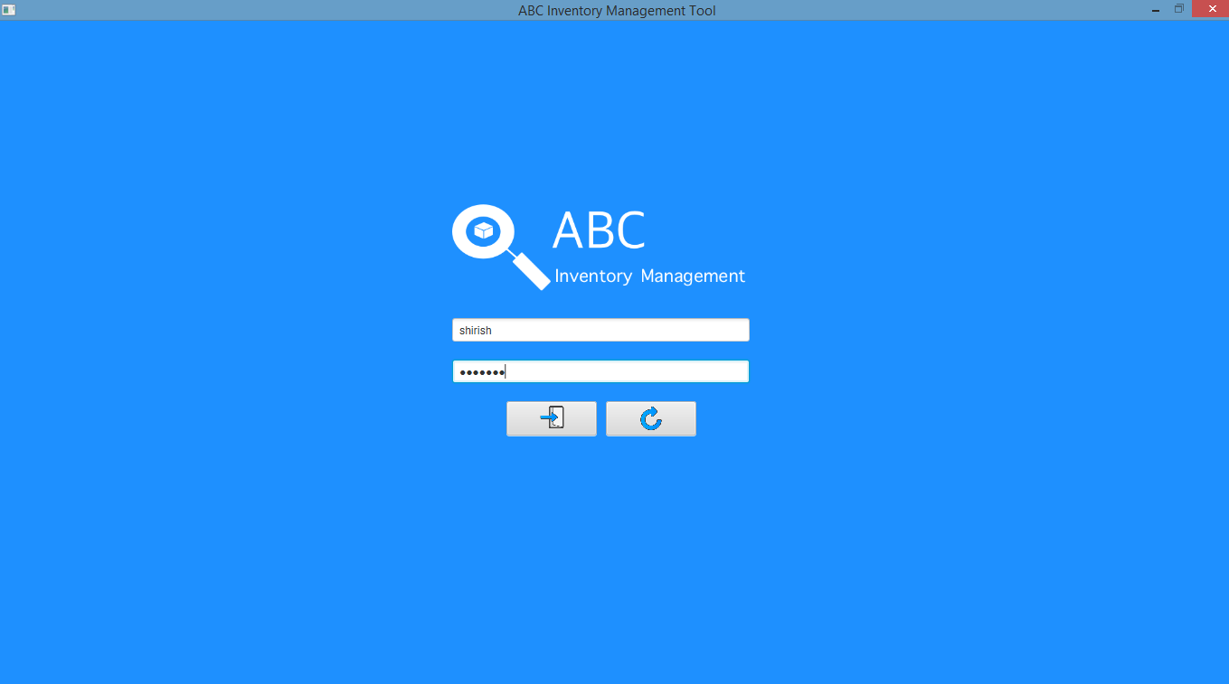

**Step 3**

After the ‘Login’ button is pressed at step 2, access is granted, and the Homepage is displayed.

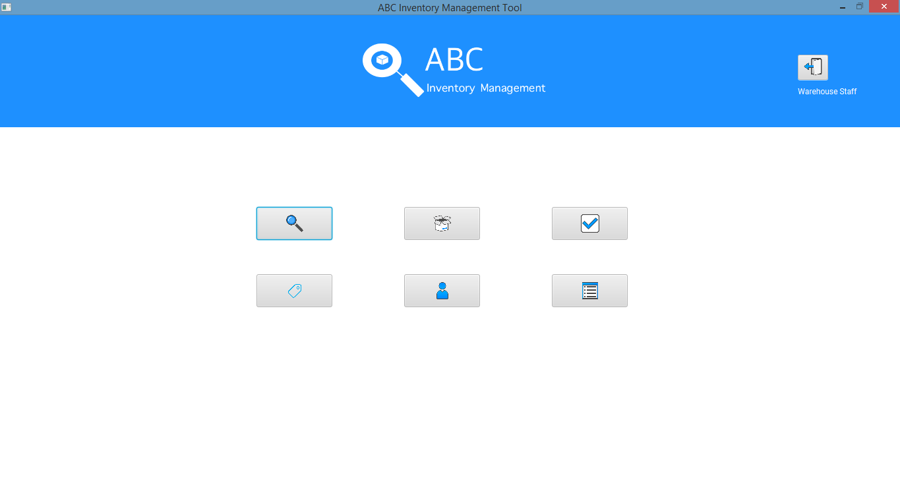

# SRP001: Search Product Script

## Script Description

This script follows each step while searching for a product in the database. This script will check if each step while searching the product is a success. If any step fails to succeed, a bug will be reported, and the test will be conducted again.

## Testing Requirements

This test will cover the Search Product functionality of the system.

## Setup

* The computer in the location is powered on.
* Make sure the computer is connected to the internet.
* Application is launched.
* Username and password are known.

## Teardown

* Conduct the SRP002 Script.

## Script Steps

|  |  |  |  |
| --- | --- | --- | --- |
| Step | Test Action | Expected Results | Pass/Fail |
|  | Click on the ‘Search Product’ button in Homepage. | System launches the ‘Search Product’ page. | Pass |
|  | Enter the product code of the product. | System waits for the user’s action. | Pass |
|  | Click on the ‘Search’ button. | System displays the product details of the product code that was entered. | Pass |

### Result Screenshots

**Step 1**

After clicking on the ‘Search Product’ button in Homepage, the system displays the ‘Search Product’ page.

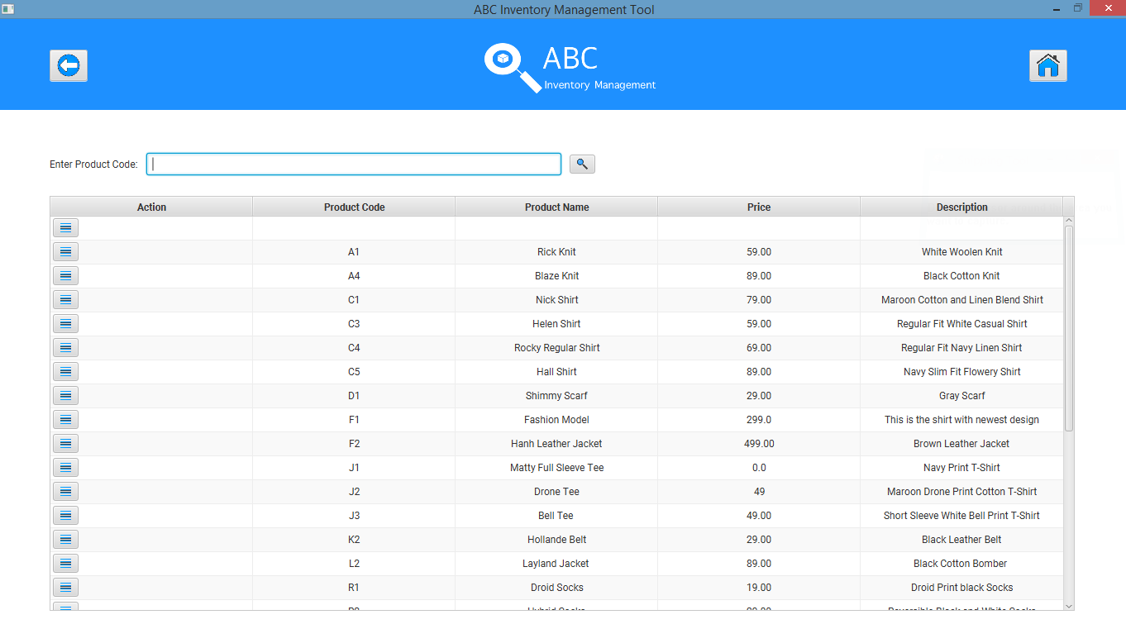

**Step 2**

User enters the ‘Product Code’ of the product that needs to be searched.

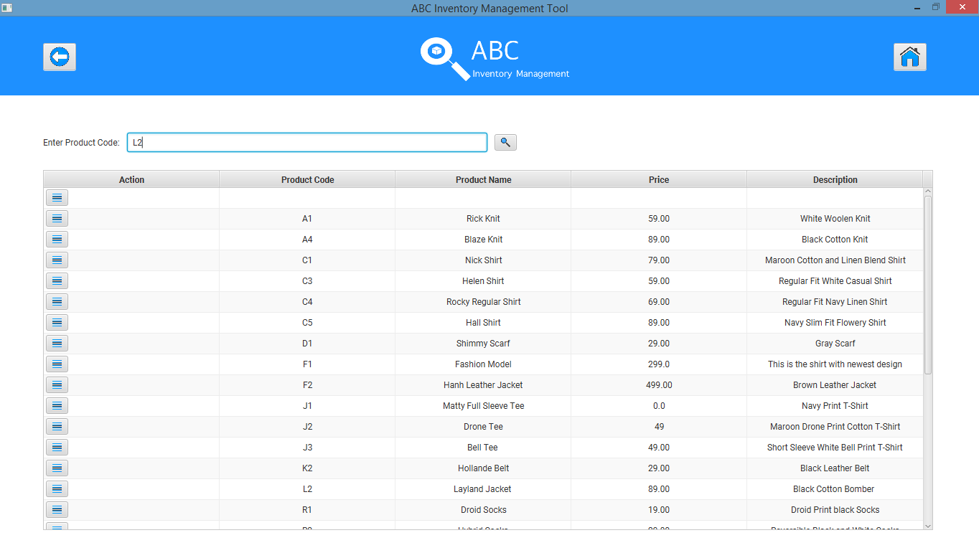

**Step 3**

After the user clicks on the ‘Search’ button, the system displays the details of the product if it exists.

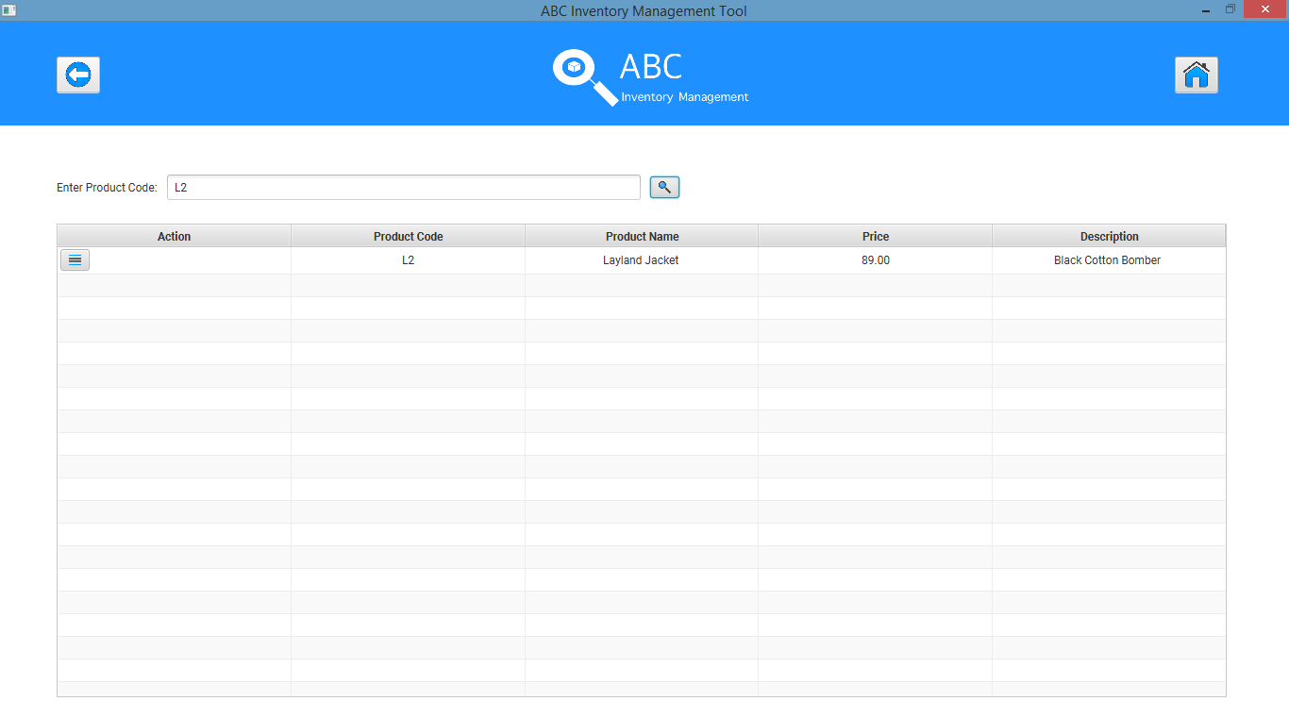

# SRP002: Search Product Quantity Script

## Script Description

This script follows each step while searching for the quantity of a particular size of the product in all location after script SRP001. This script will check if each step while searching for the quantity in each location is a success. If any step fails to succeed, a bug will be reported, and the test will be conducted again.

## Testing Requirements

* This test will cover if the user can check product size content in different location.

## Setup

* SRP001 is completed.

## Teardown

* User can use any other functionality of the system.

## Script Steps

|  |  |  |  |
| --- | --- | --- | --- |
| Step | Test Action | Expected Results | Pass/Fail |
| 1. | User clicks on the ‘Detail’ button in the action column of the Product searched from SRP001. | System displays the various Product item (Sizes) that exist for the product. | Pass |
| 2. | User clicks on the ‘Detail’ button in the action column for the size they wish to view the quantity in each location for. | System displays the quantity of the size in each location where the product size exists along with the details of the location. | Pass |

### Result Screenshots

**Step 1**

After user conducts SRP001 and clicks on the ‘Details’ button of the product in the action column, the product items (sizes) that exist for the product along with other details is displayed.

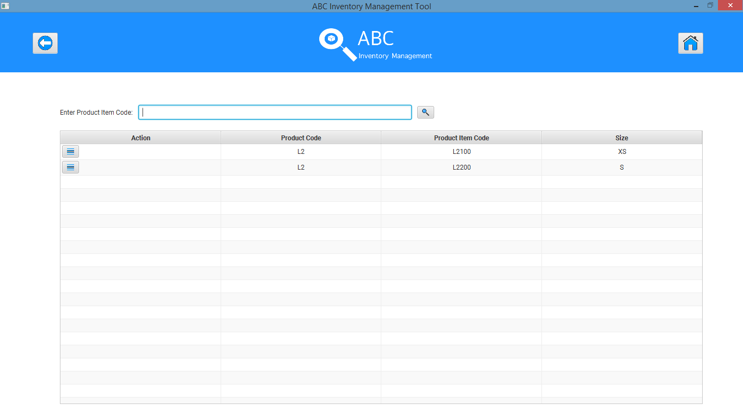

**Step 2**

After user clicks on the ‘Detail’ button in the action column for the size they wish to view the quantity in each location for, the quantity of size in each location where the product size exists along with the details of the location is displayed.

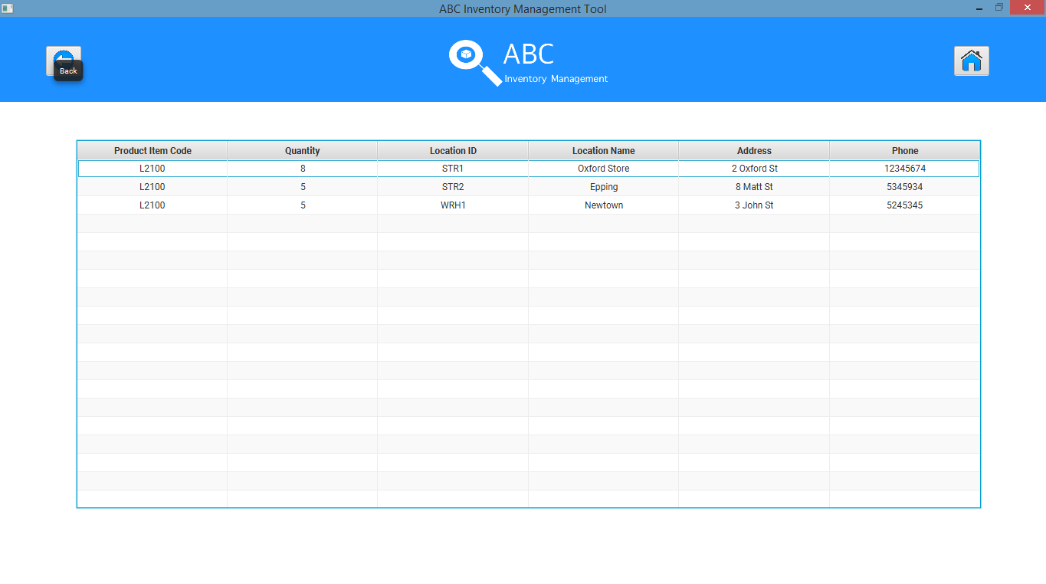

# SP001: Send Product Script

## Script Description

This script follows each step while sending a product to another location then attempting to accept it through the same account. This script will check if each step while sending the product is a success. If any step fails to succeed, bug will be reported, and the test will be conducted again.

## Testing Requirements

This test will cover the Send Product functionality of the system.

## Setup

* The computer in the location is powered on.
* Make sure the computer is connected to the internet.
* Application is launched.
* Username and password are known.

## Teardown

* Product can be accepted in the destination location by the staff that belong to the destination location by logging in to the system and then using the Accept Product functionality.

## Script Steps

|  |  |  |  |
| --- | --- | --- | --- |
| Step | Test Action | Expected Results | Pass/Fail |
| 1. | Click on the ‘Send Product’ button. | System launches the ‘Send Product’ page. | Pass |
| 2. | Select a location to send the products to. | System waits for the user’s action. | Pass |
| 3. | Enter a description for the transfer being made. | System waits for the user’s action. | Pass |
| 4. | Select product if it is already displayed in the Table View and the click on the ‘->’ button to add the product to the cart. | System adds the selected product to the cart with quantity as 1. | Pass |
| 5. | Double click on the quantity of the cart to change the quantity to be sent and press enter. | System changes the quantity value in the cart. | Pass |
| 6. | Enter product item (size) code in the search section and click on the ‘Search’ button. | Display the product item (size) if it exists in the location that the staff logged in belongs to. | Pass |
| 7. | Repeat Step 7 and 8. | Repeat Step 7 and 8. | Pass |
| 8. | Click on the ‘Send Product’ button. | System displays a message saying the Transfer Items have been added. | Pass |
| 9. | Click on ‘Main Menu’ button at the top right corner. | System displays the Homepage | Pass |
| 10. | Click on ‘Accept Product’ button. | System displays the ‘Accept Product’ page but does not display the product that was sent earlier in step 11. | Pass |
| 11. | Physically pack the products selected as to be sent and use an external delivery system to physically send the products to Store 1 (Oxford Store). | N/A | N/A |

### Result Screenshots

**Step 1**

After the user clicks on the ‘Send Product’ button at Homepage after which the ‘Send Product’ page is displayed.

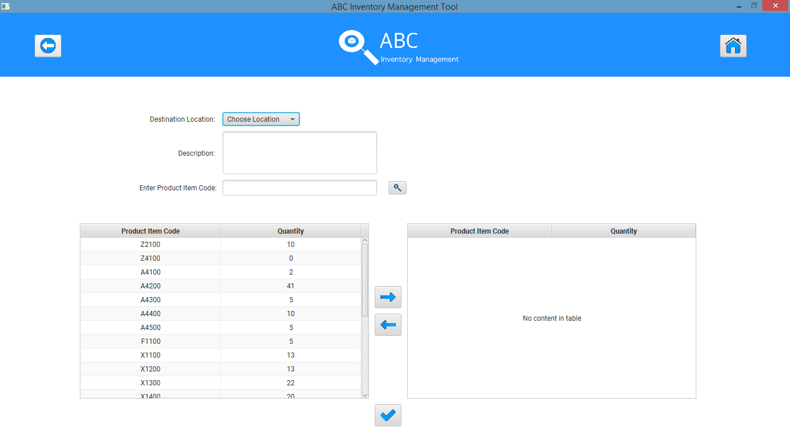

**Step 2**

‘Oxford Store’ is selected as the destination location.

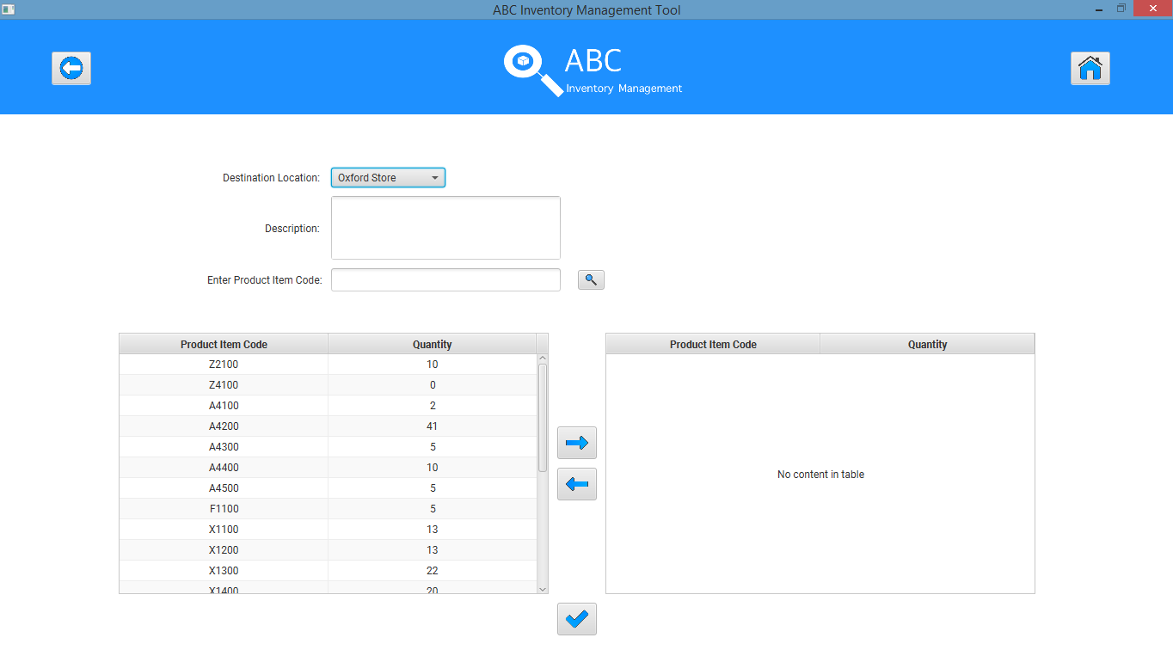

**Step 3**

A description is entered for the transfer.

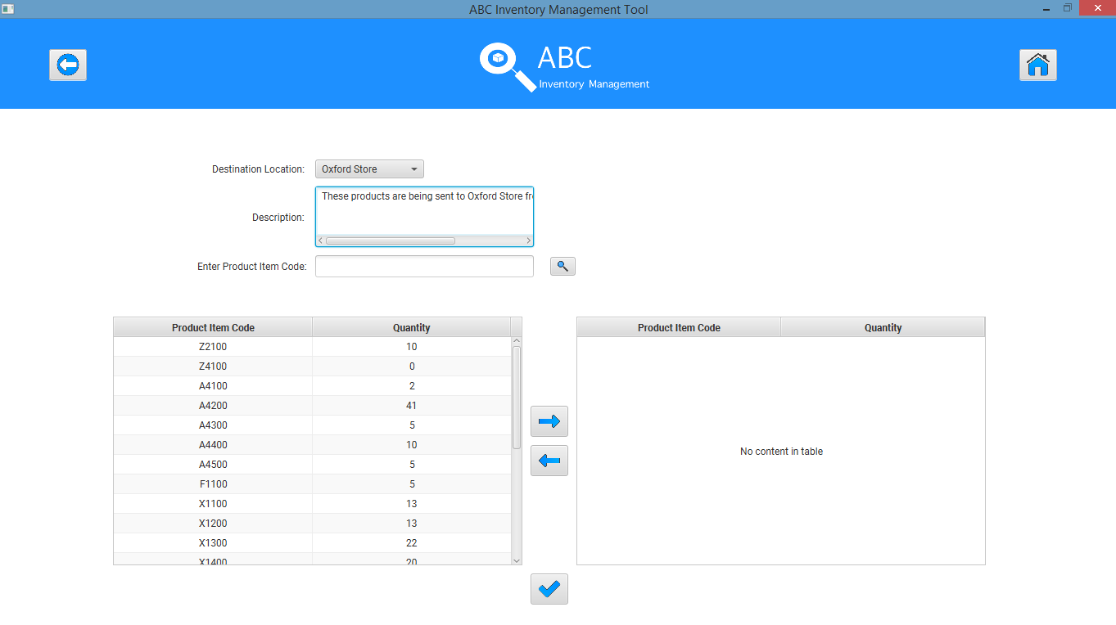

**Step 4**

A product if it is already displayed in the list is selected.

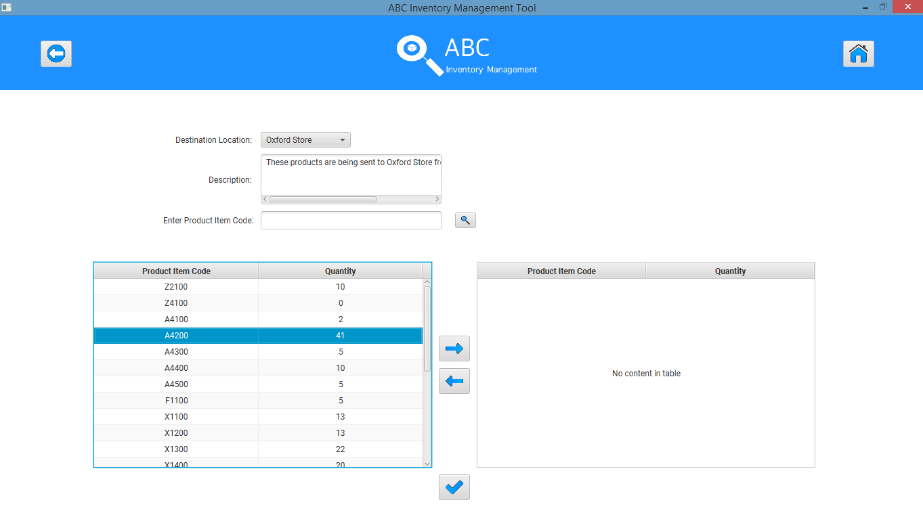

‘->’ button is clicked to add the product to the cart with quantity 1.

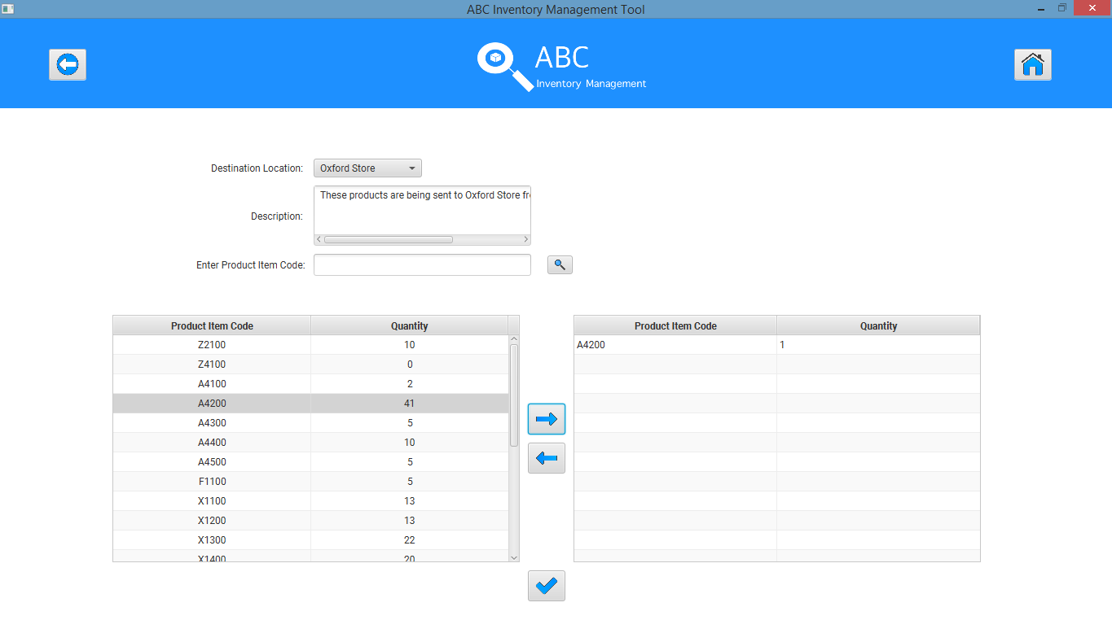

**Step 5**

Quantity in the cart side is double clicked which makes it editable.

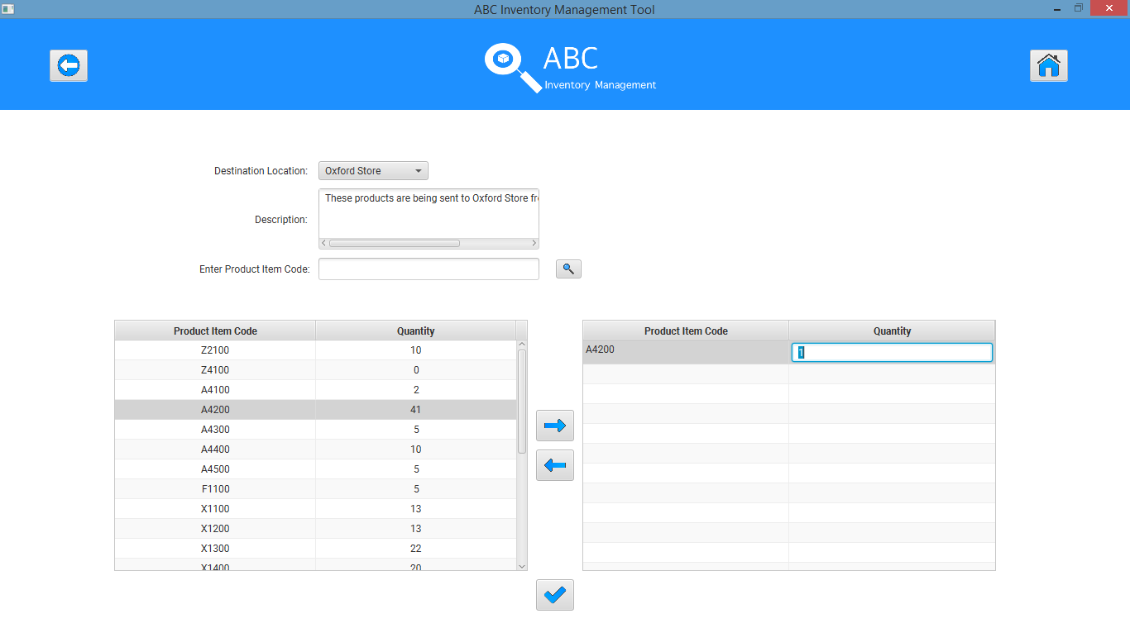

Quantity that is wished to be sent is entered and enter key is pressed.

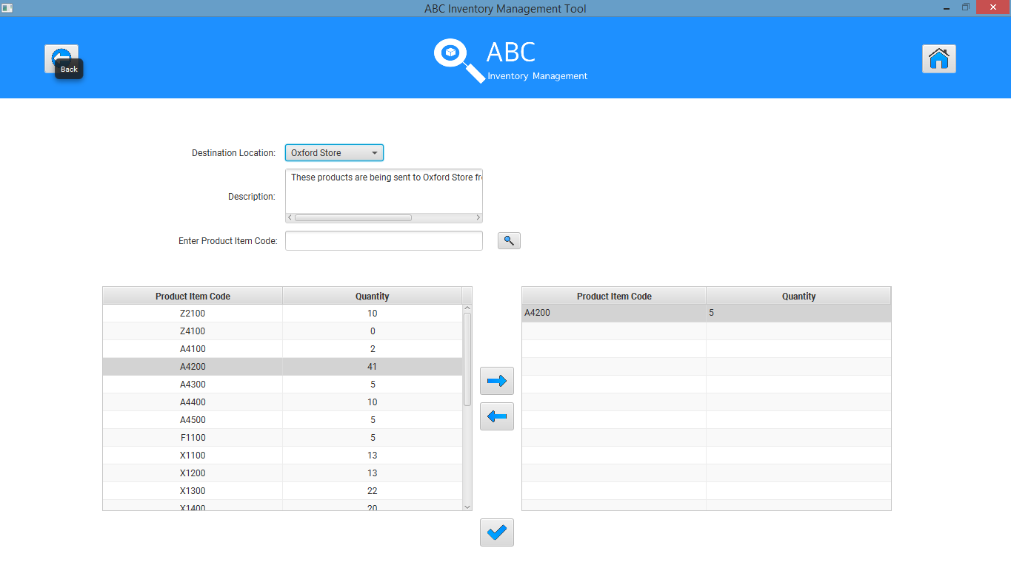

**Step 6**

A product item code (L2100) (XS) is entered in the search field and the search button is clicked.

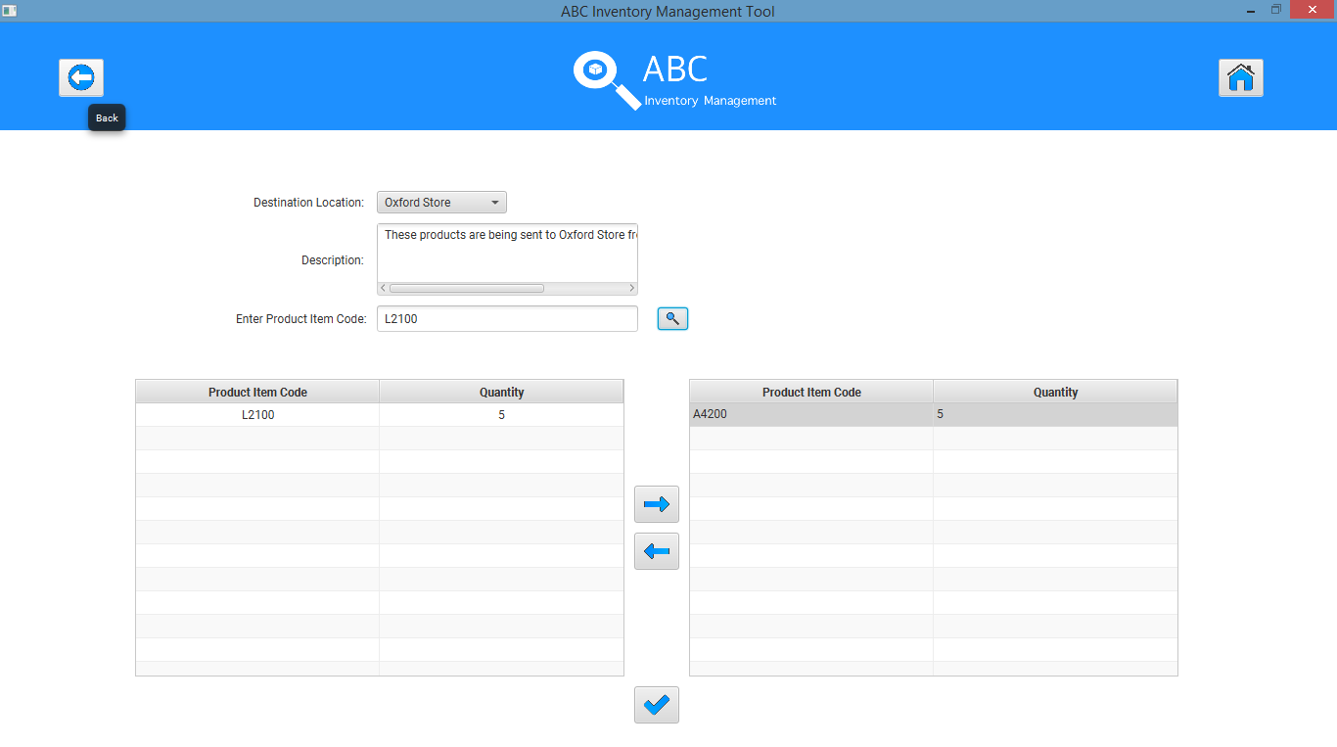

**Step 7**

Add the size to the cart but leave the quantity as 1.

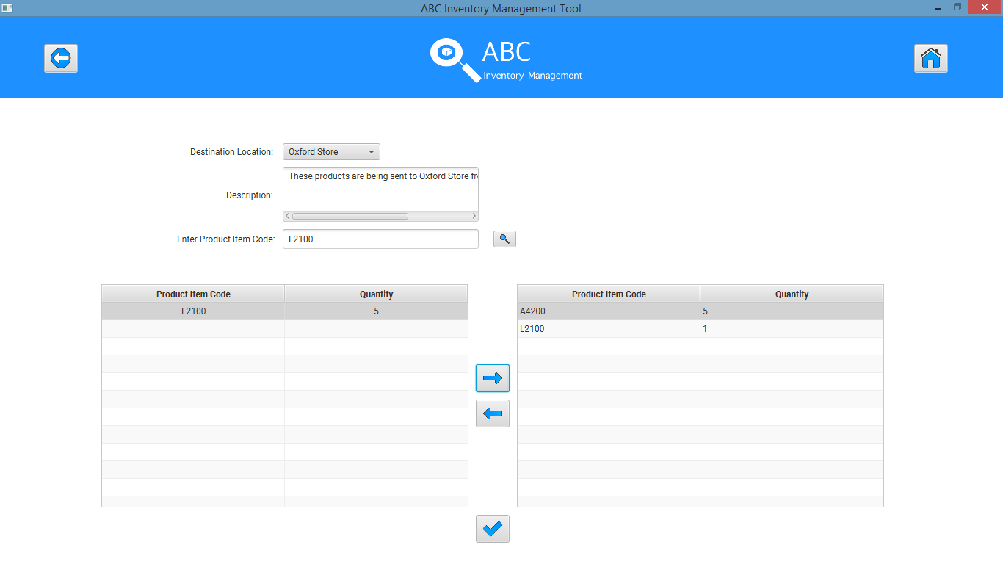

**Step 8**

Message displayed by the system.

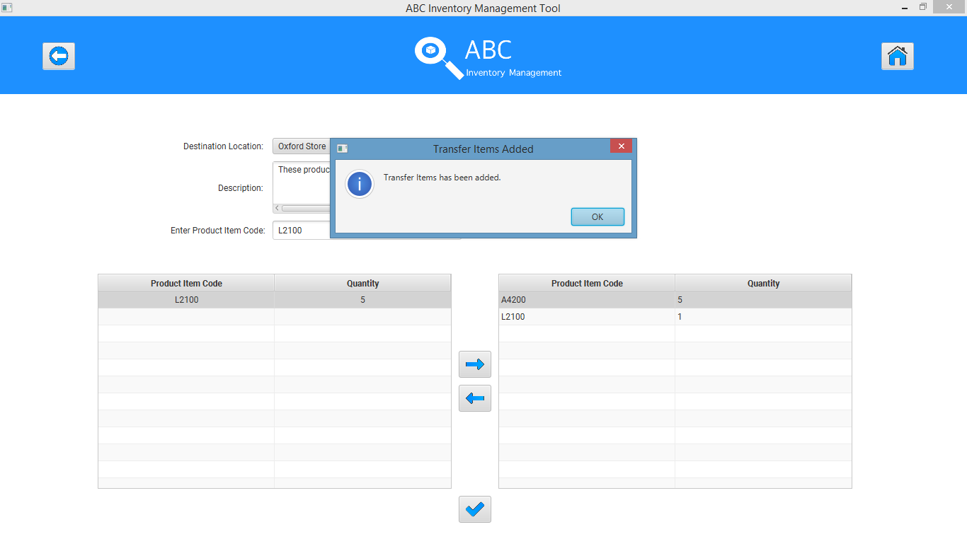

**Step 9**

Homepage after the user clicks on the ‘Main Menu’ button.

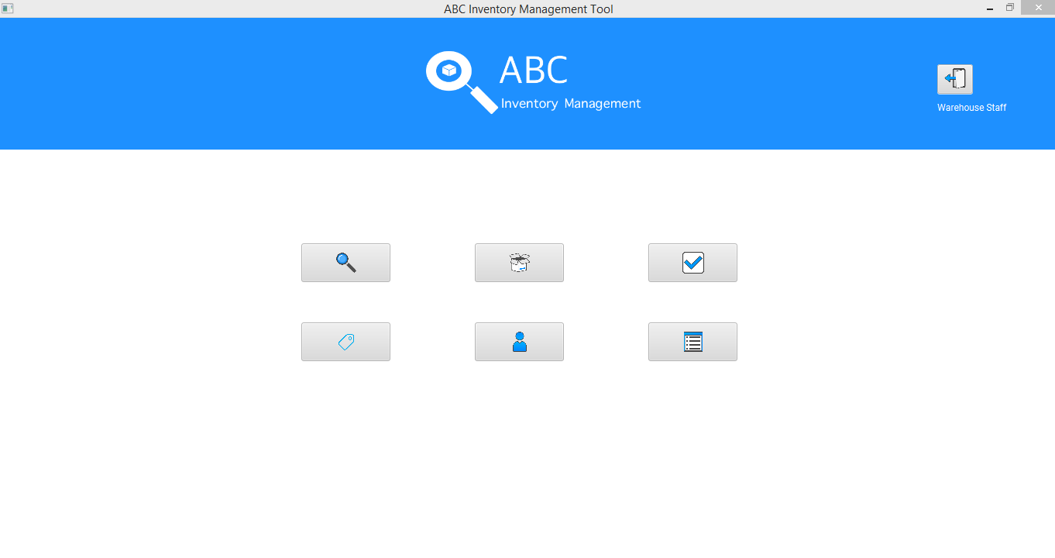

**Step 10**

Empty ‘Accept Product’ page because the user a warehouse staff sent the products from warehouse to a store. Only the staff belonging to the destination location can view the transfer.

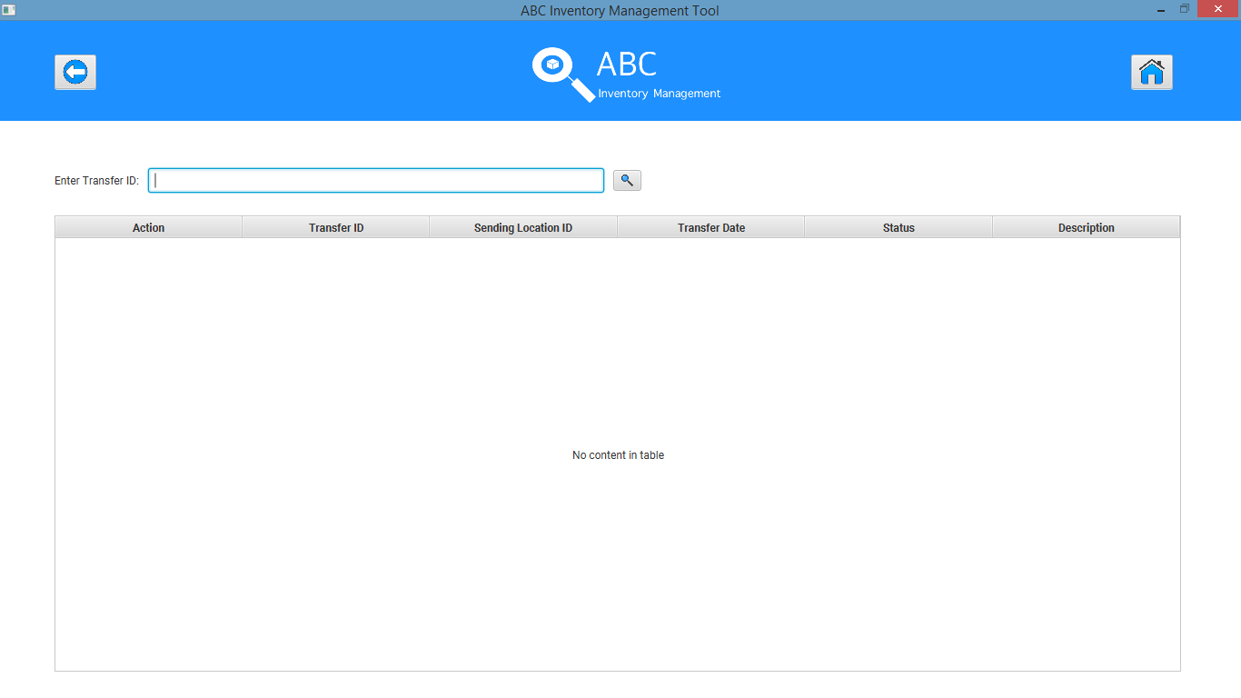

The quantity being adjusted from the sending location ‘Newtown Warehouse’:

A4200 quantity in Newtown warehouse was 41. After 5 items were sent to Oxford Store the quantity has been adjusted to 36.

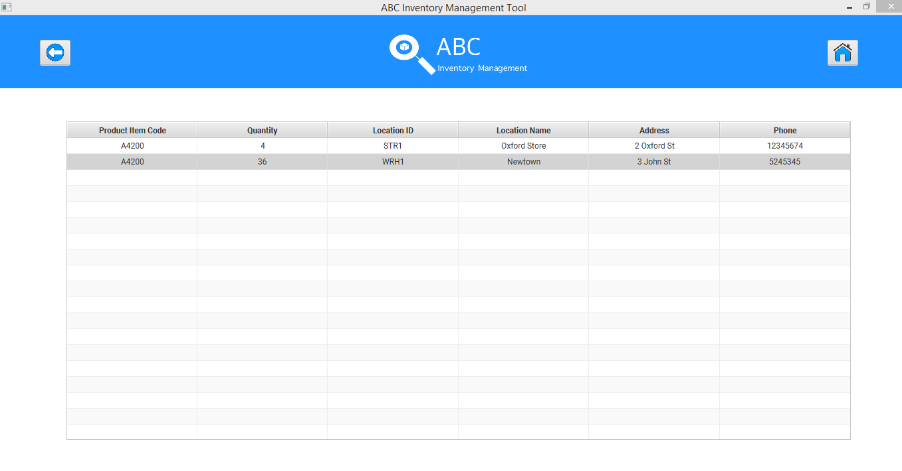

L2100 quantity in Newtown warehouse was 5. After 1 item was sent to Oxford Store the quantity has been adjusted to 4.

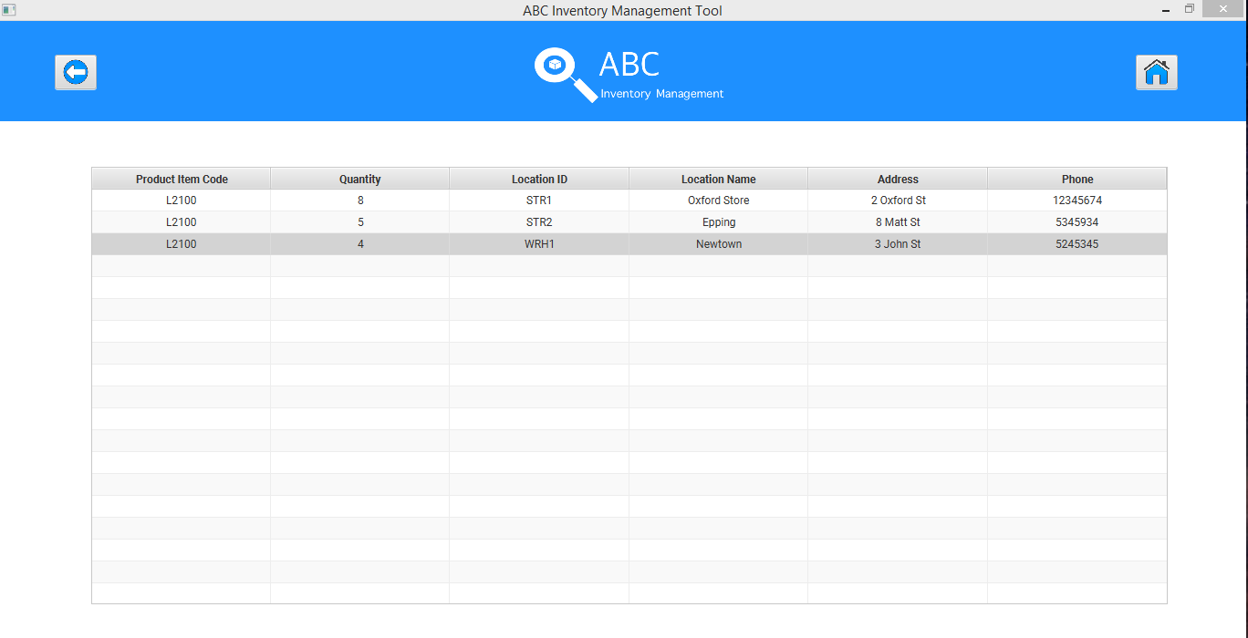

# GR001: Generate Report Script

## Script Description

SP001 shows that the product is sent however when the same user goes and checks the accept product list to accept the product sent, it is not available. This is because the system only allows the user belonging to the destination location to accept the products sent. This script will show that the sent product transfer did occur and it can be checked through the generate report feature of the system. This allows the user who sent the products to check the transfer. This script follows each step while generating a report of all transfers. This script will check if each step while generating a report in the system is a success. If any step fails to succeed, a bug will be reported, and the test will be conducted again.

## Testing Requirements

This test will cover the Generate Report functionality of the system.

## Setup

* The computer in the location is powered on.
* Make sure the computer is connected to the internet.
* Application is launched.
* Transfer (Product sending and accepting) has been done through the system.

## Teardown

* User can check each item in a transfer.

## Script Steps

|  |  |  |  |
| --- | --- | --- | --- |
| Step | Test Action | Expected Results | Pass/Fail |
|  | Click on the ‘Generate Report’ button in Homepage. | System launches the ‘Generate Report’ page. | Pass |
|  | Look for the transfer in the list displayed (transfers can be filtered according to the date sent) and check the status of the transfer. | System waits for the user’s action. | Pass |
|  | Click on the ‘Details’ button. | System displays the product item details of the products that were sent in the transfer. | Pass |

### Result Screenshots

**Step 1**

After clicking on the ‘Generate Report’ button in homepage, the generate report page is displayed which lists all the transfers that have occurred along with its details like ID, sending location, destination location, date, status and description.

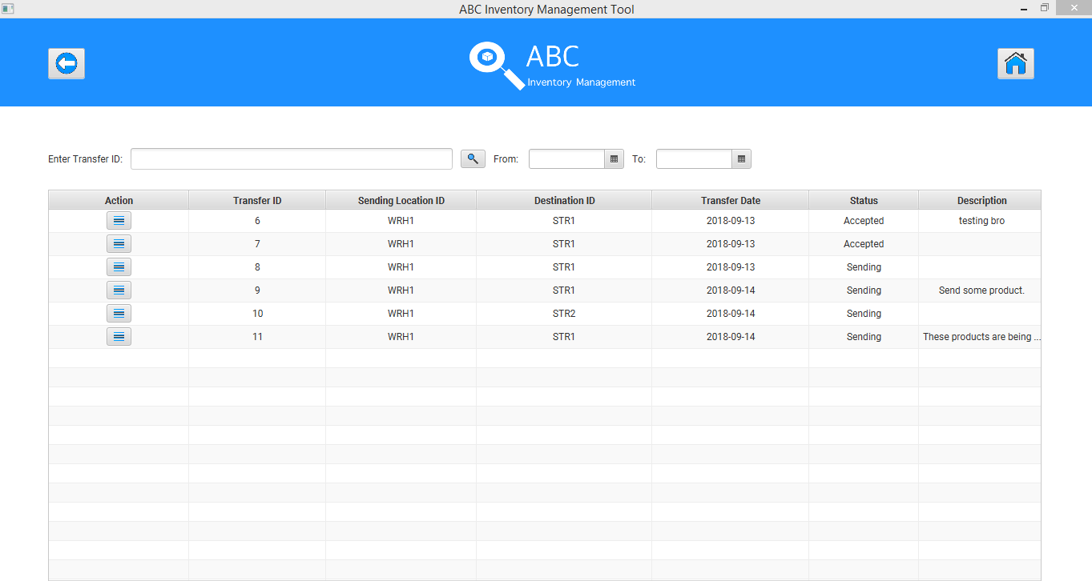

**Step 2**

User selects the most recent transfer that occurred. This is the transfer that includes all the products that were sent to store 1. This is known from the description and the date.

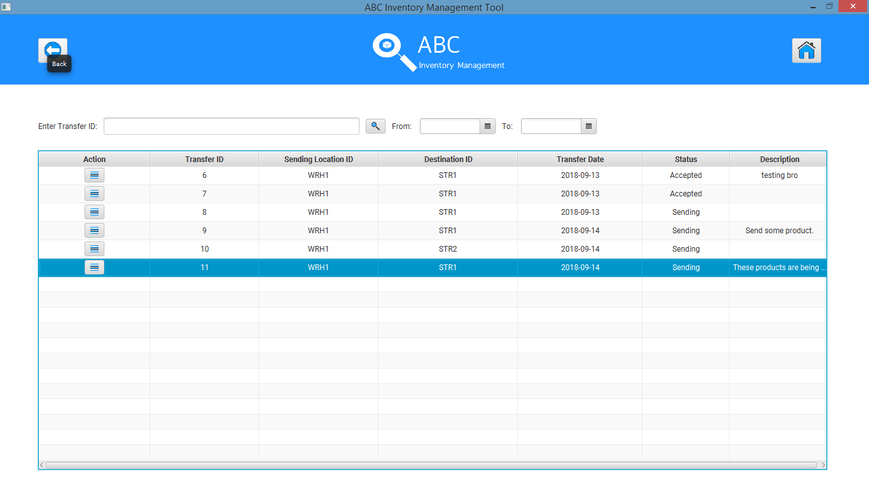

**Step 3**

After user clicks on the ‘Details’ button, all the product items that was included in the transfer along with the quantity is displayed.

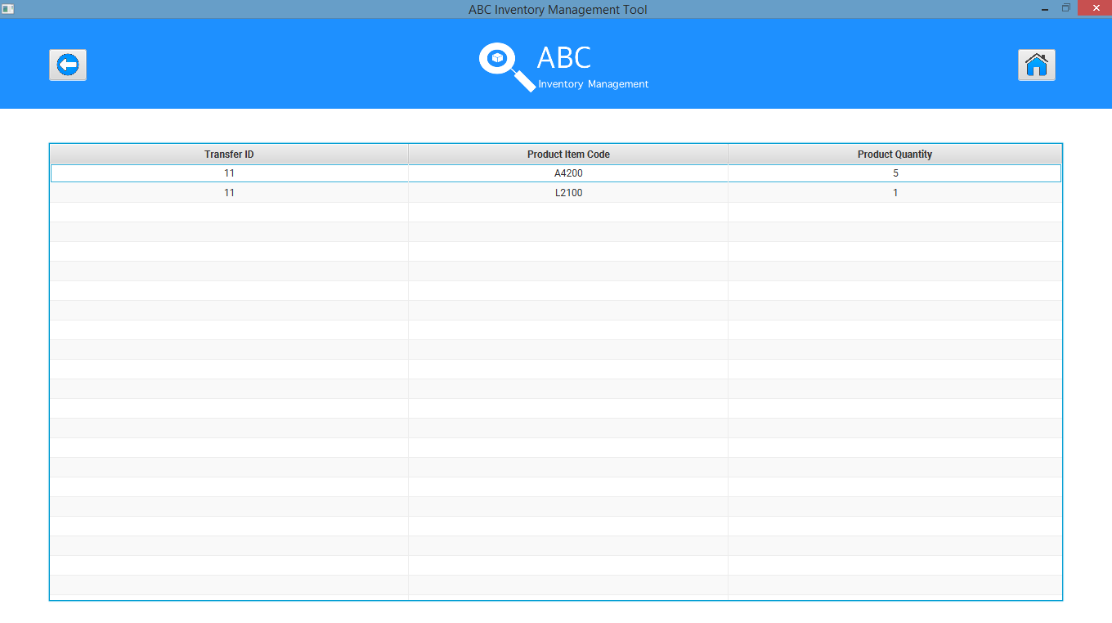

# LIS001: Logout Script

## Script Description

This script follows each step while logging out from the system. This script will check if each step while logging out from the system is a success. If any step fails to succeed, a bug will be reported, and the test will be conducted again.

## Testing Requirements

This test will cover the logout functionality of the system.

## Setup

* The computer in the location is powered on.
* Make sure the computer is connected to the internet.
* Application is launched.
* Staff is logged in.

## Teardown

* User is logged out from the system.

## Script Steps

|  |  |  |  |
| --- | --- | --- | --- |
| Step | Test Action | Expected Results | Pass/Fail |
| 1. | User clicks on ‘Main Menu’ button at the Generate Report screen. | System displays the homepage. | Pass |
| 2. | User clicks on the ‘Logout’ button. | System displays a dialog box asking user to confirm logout action. | Pass |
| 3. | Click on the ‘Yes’ button. | System logs user out of the system and displays the login screen. | Pass |

### Result Screenshots

**Step 1**

Homepage is displayed after the user clicks on ‘Main Menu’ button at generate report screen.

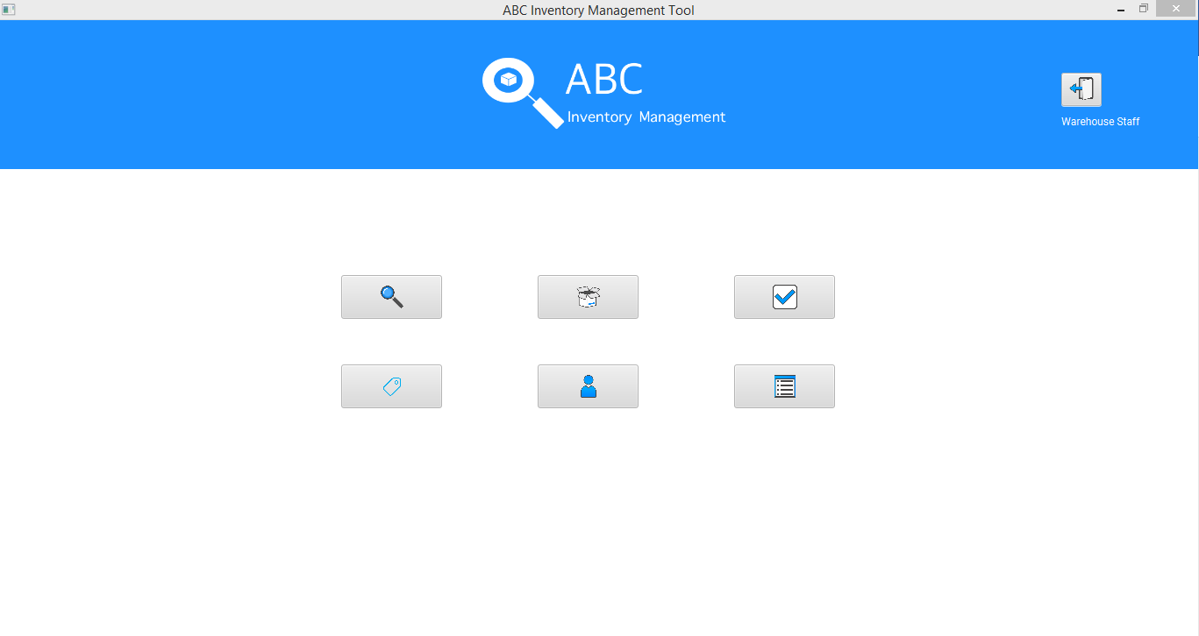

**Step 2**

After user clicks on the ‘Logout’ button, the system displays a dialog box asking user to confirm logout action.

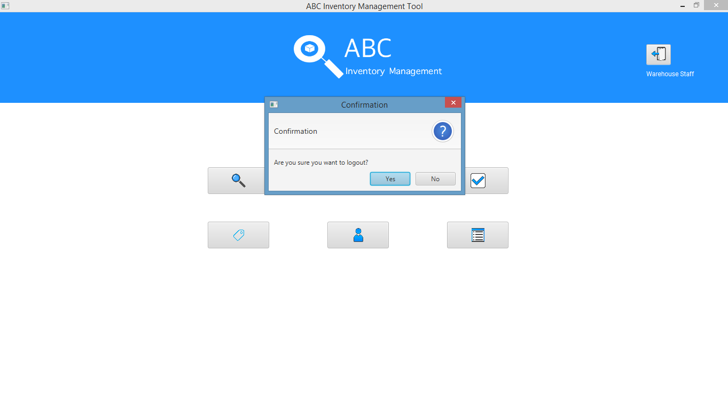

**Step 3**

User is logged out and the system displays the login page after user clicks on ‘Yes’.

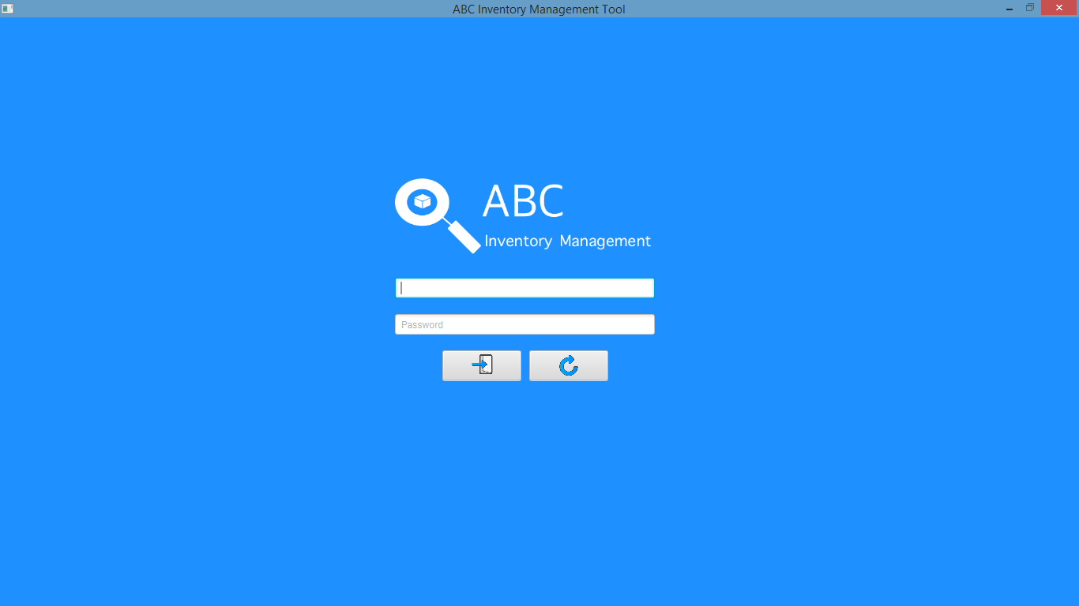

# AP001: Accept Product Script

## Script Description

This script follows each step while accepting a product by a store 1 staff which was sent from the warehouse. This script will check if each step while logging in into the system is a success. If any step fails to succeed, a bug will be reported, and the test will be conducted again.

## Testing Requirements

This test will cover the Accept Product functionality of the system.

## Setup

* The computer in the location is powered on.
* Make sure the computer is connected to the internet.
* Application is launched.
* Store Staff username and password are known.
* Products are sent

## Teardown

* Product is accepted. Product quantity in the database is updated.

## Script Steps

|  |  |  |  |
| --- | --- | --- | --- |
| Step | Test Action | Expected Results | Pass/Fail |
| 1. | Application is launched. | System displays the ‘Login’ Page with the Username and Password field empty. | Pass |
| 2. | Store staff enters username and password in the username and password field. | System waits till user to click on ‘Login’ button. | Pass |
| 3. | Click on the ‘Login’ button. | System grants access to the user and opens the Homepage (Manage staff and Manage Product options are disabled for the store staff) | Pass |
| 4. | Click on ‘Accept Product’ button at homepage. | Accept Product page is displayed and the products that were sent from the warehouse during SP001 is displayed along with all its details. | Pass |
| 5. | Look for the transfer that needs to be accepted. Transfer can be searched using transfer id or can be recognized because of the description. In case of this test, transfer is recognized through the description. | System waits for user to perform an action. | Pass |
| 6. | Click on ‘Details’ button for the transfer. | System displays the contents of the transfer sent. | Pass |
| 7. | Store staff physically counts and checks the contents of the delivery that was received. Click on ‘Accept’ button. | System displays a message saying the transfer has been accepted. | Pass |

### Result Screenshots

**Step 1**

Application launched, and login page is displayed.

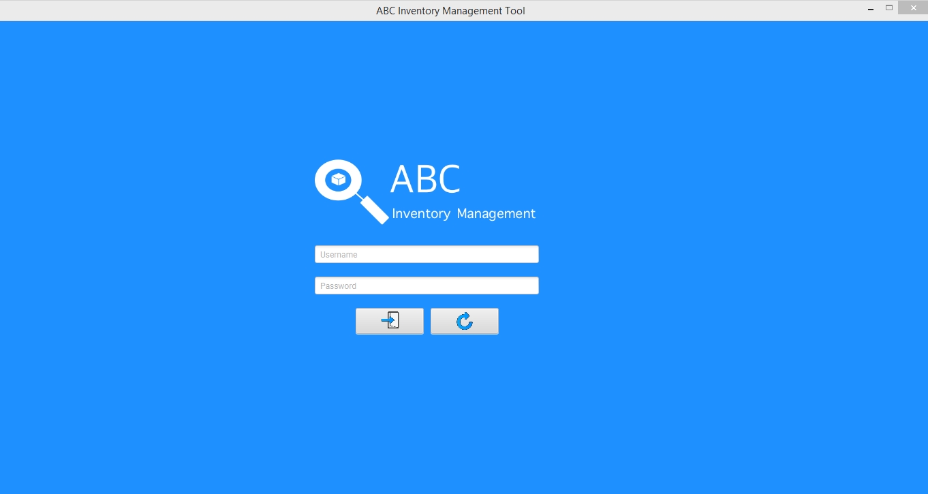

**Step 2**

Username and password are entered, and the system waits user to click on the ‘Login’ button.

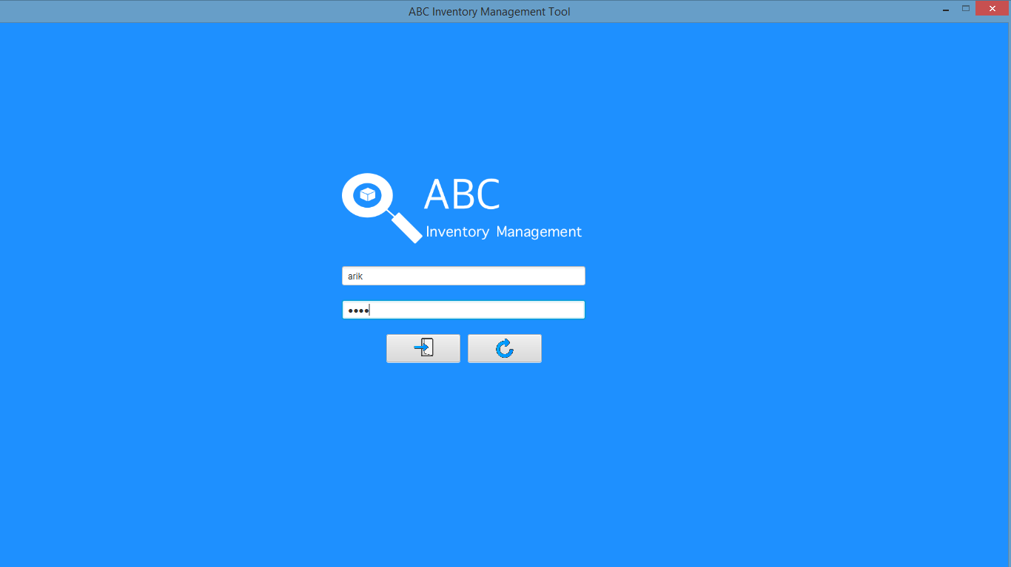

**Step 3**

After the ‘Login’ button is pressed at step 2, access is granted, and the Homepage is displayed (Manage staff and Manage Product options are disabled for the store staff).

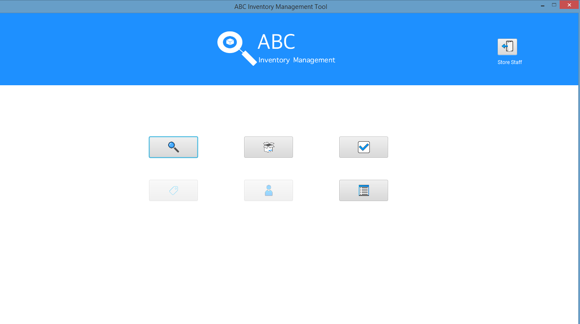

**Step 4**

Accept product page is displayed when user clicks on ‘Accept Product’ button at homepage. The products that were sent from warehouse in SP001 is displayed.

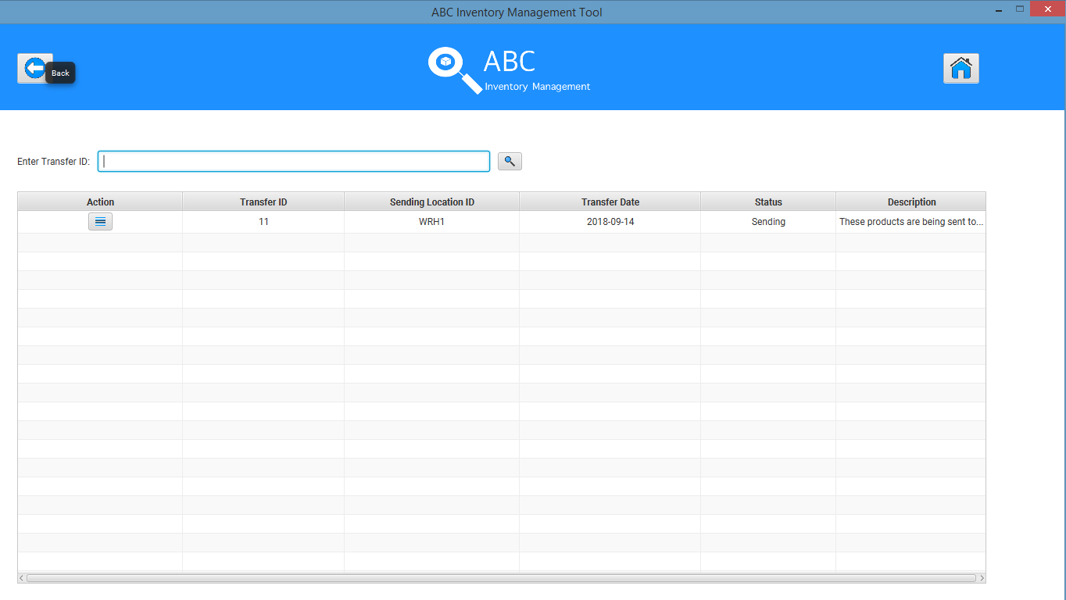

**Step 5**

User looks for the transfer to be accepted. The transfer to be accepted in this case is recognized through the description. The details button is pressed to view all the contents of the transfer. Store staff physically counts and checks the contents of the delivery that was received. Staff then clicks on the accept button.

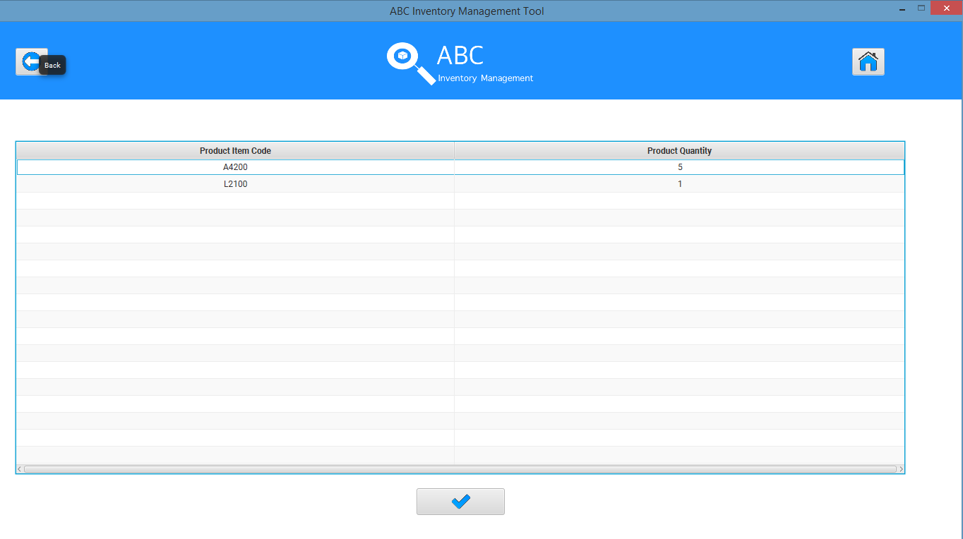

**Step 6**

System displays a message saying the transfer has been accepted.

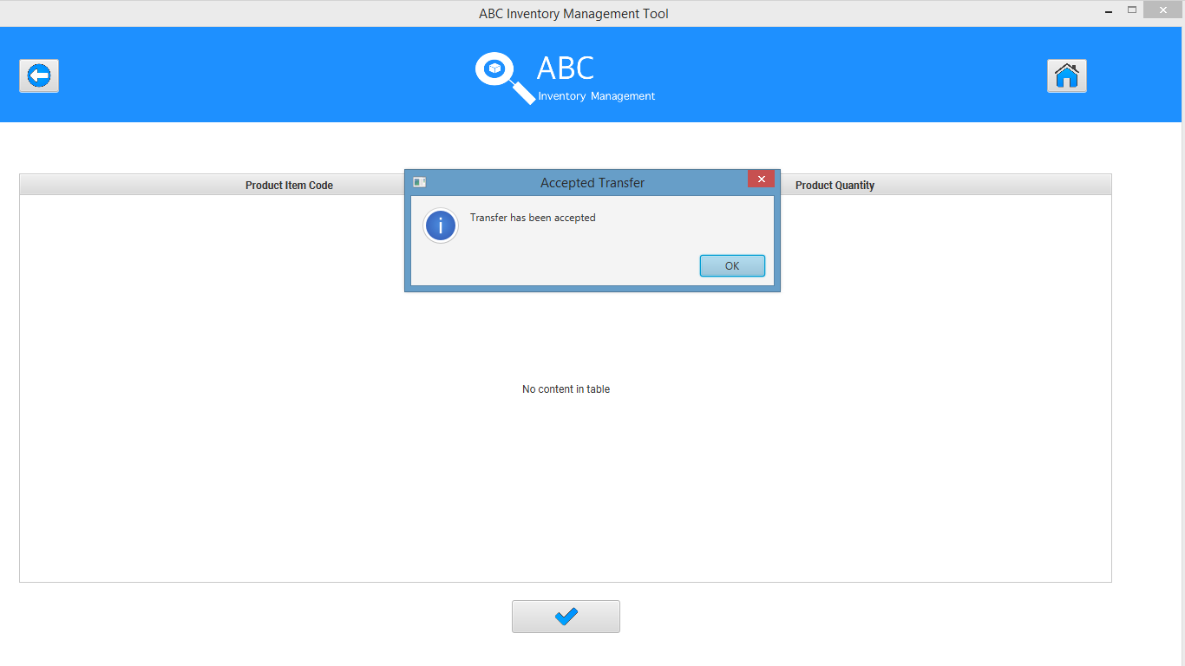

The quantity of product L2100 in Oxford Store (STR1) is updated to 9 since 1 item was sent from WRH1.

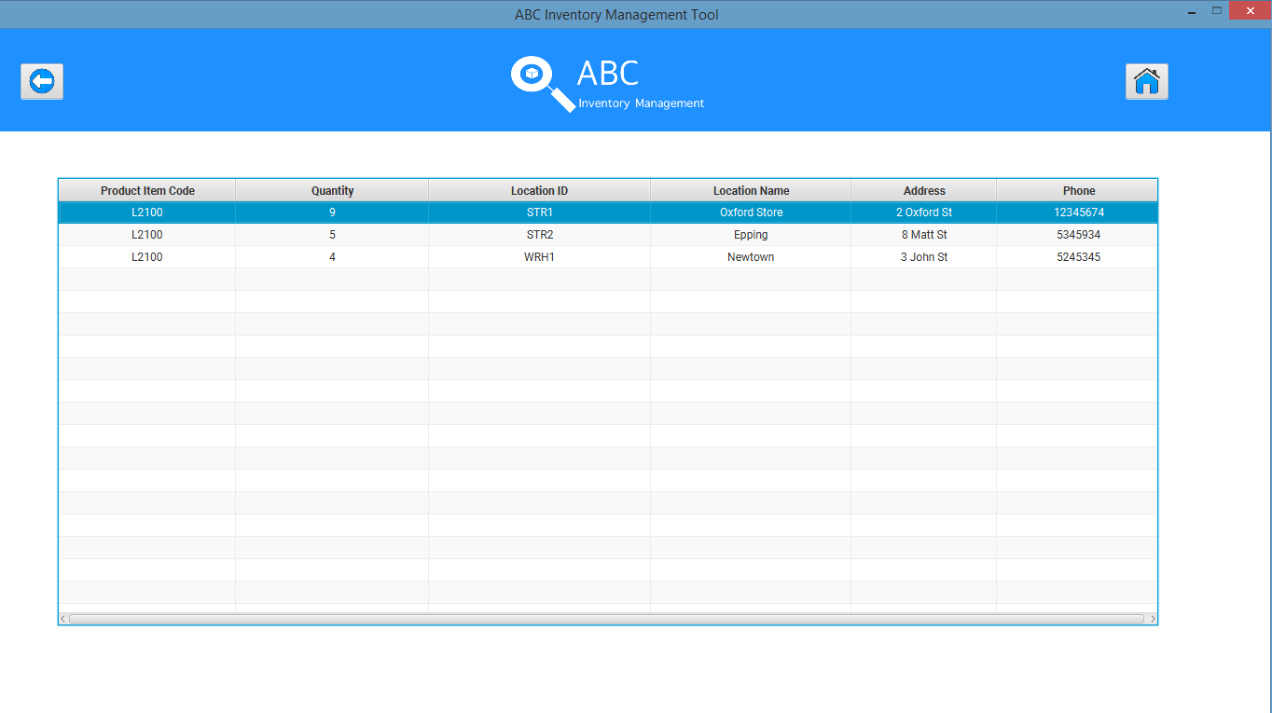

The quantity of product A4200 in Oxford Store (STR1) is updated to 9 since 5 items were sent from the Warehouse.

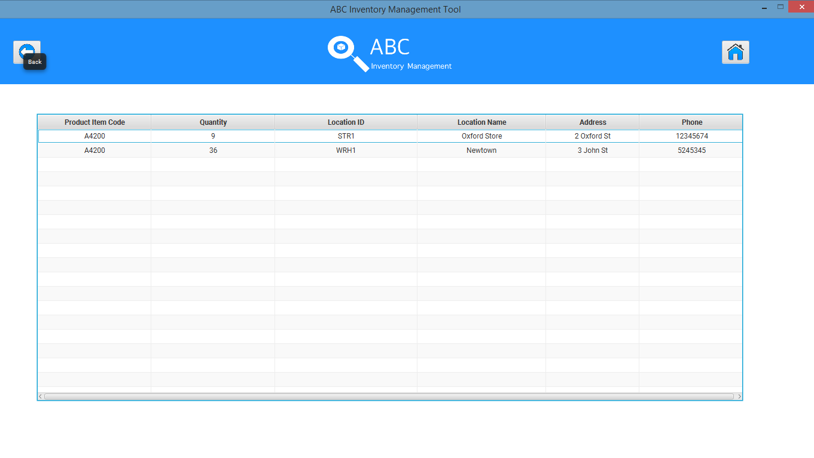

## Test Execution

|  |  |  |  |  |
| --- | --- | --- | --- | --- |
| Date/Time | Tester | Test ID | Test Phase | Status |
| 14/09/2018 | Shirish Maharjan | SM001 | Cycle 1 | Pass |
| 18/09/2018 | Shirish Maharjan | SM001 | Cycle 2 | Pass |